**Name of the GUI application**: Recipe Organizer

**Purpose of the Application**: The Recipe Organizer application provides users with a convenient way to manage and organize their recipes. It allows users to easily store, categorize, search, and retrieve recipes.

**Reason for Creating the Application**: I am creating this application to offer users a digital solution for managing their recipe collections efficiently. With the increasing trend of cooking at home and the availability of various recipes online, there is a need for a tool that can help users organize their favorite recipes in one place.

**Goals of the Application**:

1. Allow users to add new recipes manually or import them from external sources (e.g., websites, text files).
2. Provide categories or tags for organizing recipes by type (e.g., breakfast, lunch, dinner, dessert, vegetarian, vegan, etc.).
3. Enable users to search for recipes by keywords, ingredients, or categories.
4. Display recipes in a user-friendly format, including ingredients, instructions, and images.
5. Allow users to edit, delete, and update existing recipes.
6. Implement a user-friendly and intuitive graphical user interface using Python tkinter for seamless navigation and interaction.

**Target Audience**: The target audience for the Recipe Organizer application includes individuals who enjoy cooking and want to streamline the process of managing their recipes. They could be home cooks, amateur chefs, or anyone looking to organize their culinary inspirations. The target audience may vary in age but generally comprises adults (18+) of all genders and socioeconomic backgrounds who have access to computers or devices running Python.

**Outline of the Final Python tkinter GUI application**:

1. **Main Window**:
   * Welcome message and brief introduction to the application.
   * Options to add, search, view, edit, or delete recipes.
   * Categories or tags for organizing recipes.
2. **Add Recipe Window**:
   * Form for entering recipe details such as name, category, ingredients, instructions, and optional image upload.
   * Buttons to save, cancel, or reset the form.
3. **Search Recipe Window**:
   * Text entry field for searching recipes by keywords or ingredients.
   * Dropdown menu for filtering recipes by category.
   * Search results are displayed in a scrollable list with options to view, edit, or delete.
4. **View Recipe Window**:
   * Detailed view of a selected recipe, including name, category, ingredients, instructions, and image (if available).
   * Buttons to edit or delete the recipe.
5. **Edit Recipe Window**:
   * Pre-fill out the form with the details of the selected recipe for editing.
   * Buttons to save changes or cancel.
6. **Delete Confirmation Dialog**:
   * Confirmation dialog box when deleting a recipe to prevent accidental deletions.
7. **Menu Bar**:
   * Options to import/export recipes, create backups, or exit the application.
8. **Help/About Window**:
   * Information about the application, version, author, and how-to instructions.

Following this outline, the Recipe Organizer application will provide users with a comprehensive solution for managing their recipes efficiently.

**Example of a visual flow chart**

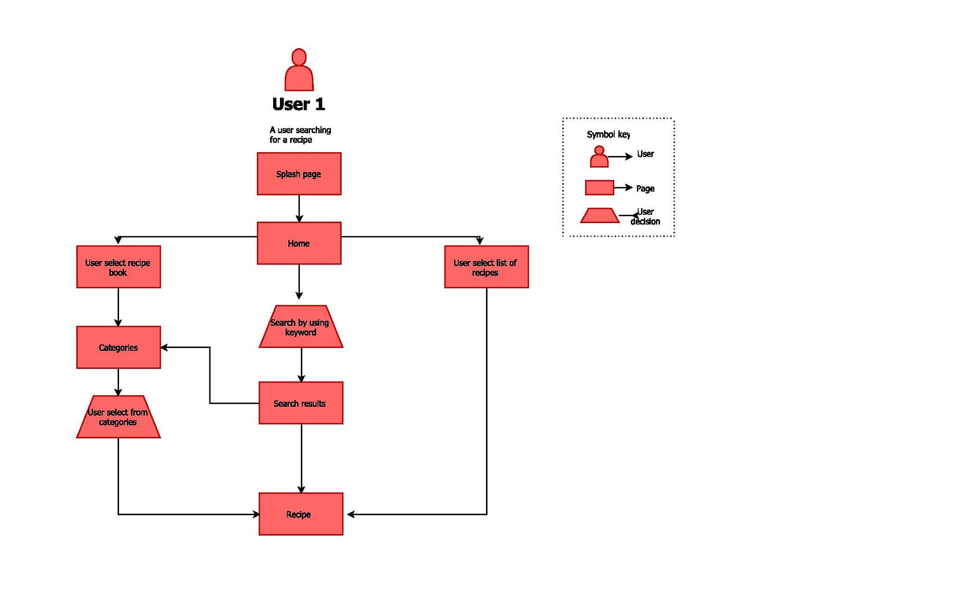 Top of Form